18-2-2015 – 200 frame burst

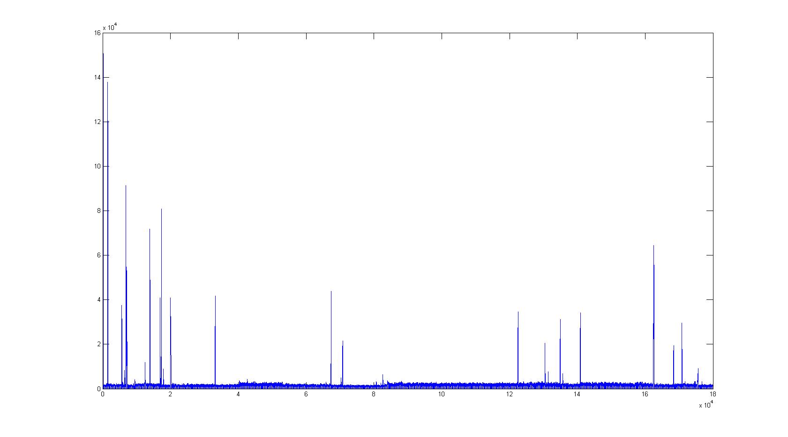

22-2-2015 – 200 burst (saving frames)

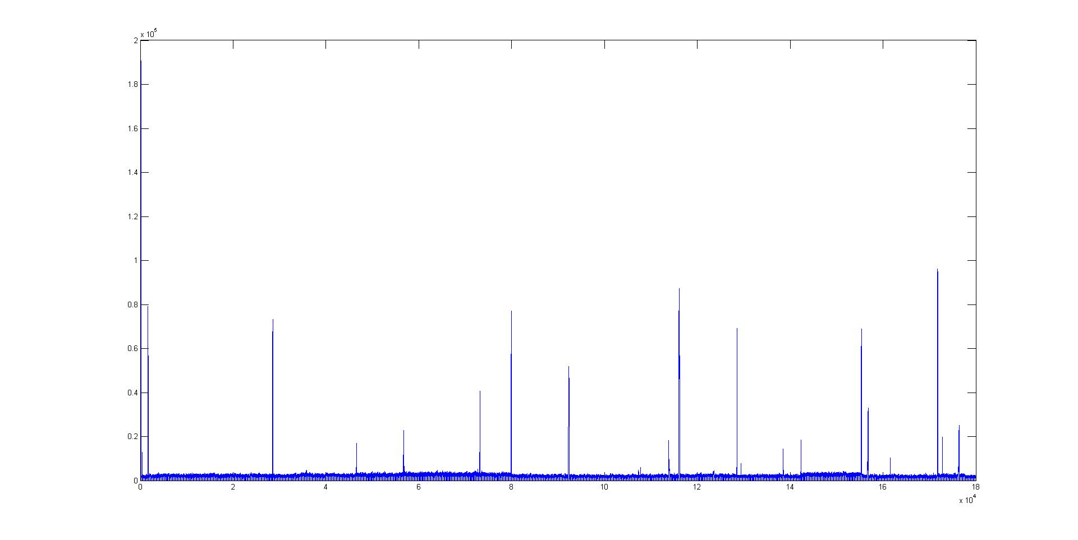

23-2-2015 - 200 burst (saving frames)

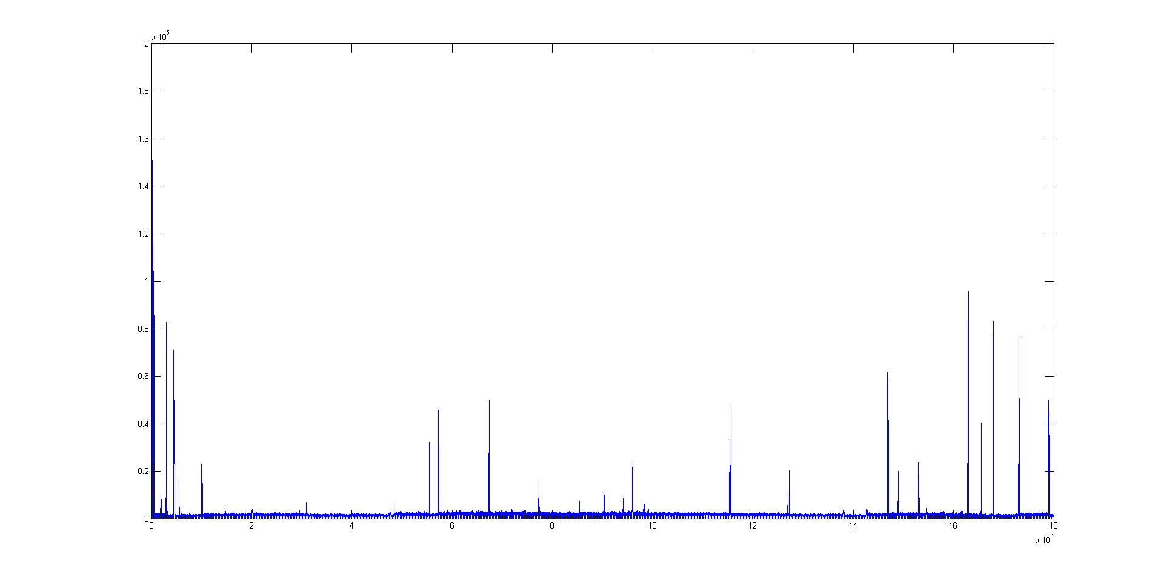

6-3-2015 – 400 frame burst (saving frames)

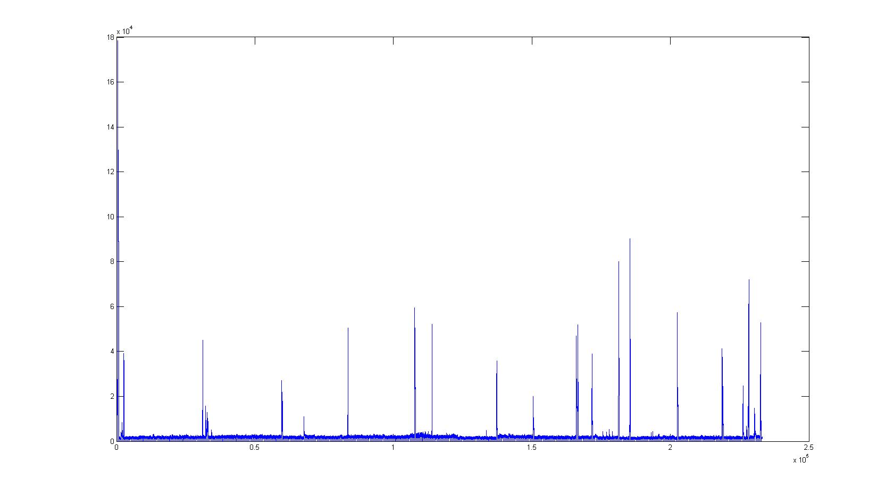

7-3-2015 – 400 frame burst

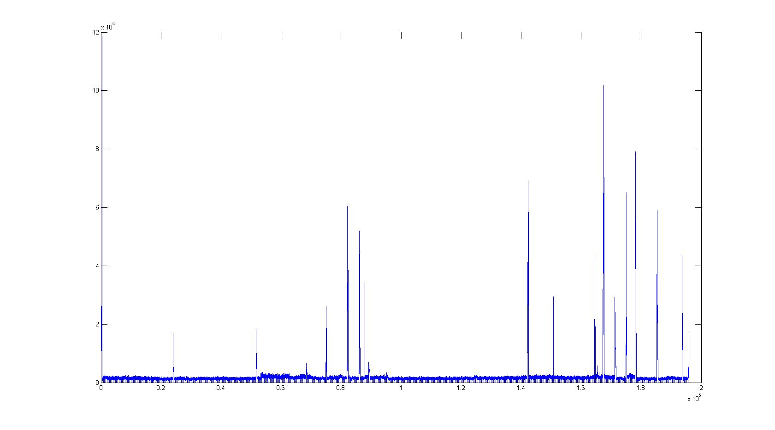

8-3-2015 – 600 frame burst (saving frames)

